

**Smart LabAssist-32**

**Fully automated magnetic bead-based nucleic acid extraction system,**

SLA-32 is applied to ectract nuclic acid and proteins by magnwtic system, Easy to use system can process to 16 - 32 samples simultaneously within 40 to 60 min, to obtain high purity nucleic acid. Dedicated reagent kits are easy to use by adding samples into pre-filled reagent plates and tubes.

SLA-32 achieves great consistency through a faster and easier extraction process compared to the spin column system.

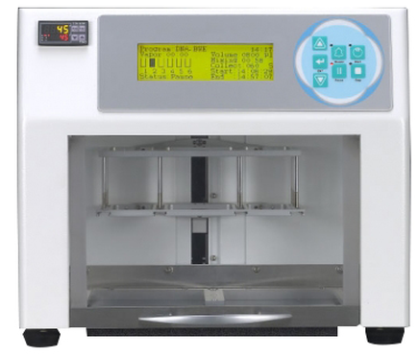

**Maelstrom 9600**

**Revolutionizing Magnetic Bead Handling, Maximize Throughput and Eliminate Cross-Contamination**

The Maelstrom 9600 is an extraction instrument fully automated and designed for high-throughput 96 samples can be processed simultaneously with Specialized spin tips enable efficient mixing of magnetic beads with a larger processing volume. With an intuitive user interface and flexible programming.

Simultaneous processing and purification of DNA, RNA samples and Automation of complicated manual steps.

Independent temperature control modules ensure stability of purification performance and Processing volume up to 1,600µl with Spin tips stir magnetic beads at speeds up to 3000 rpm, Effective prevention of aerosol cross-contamination.

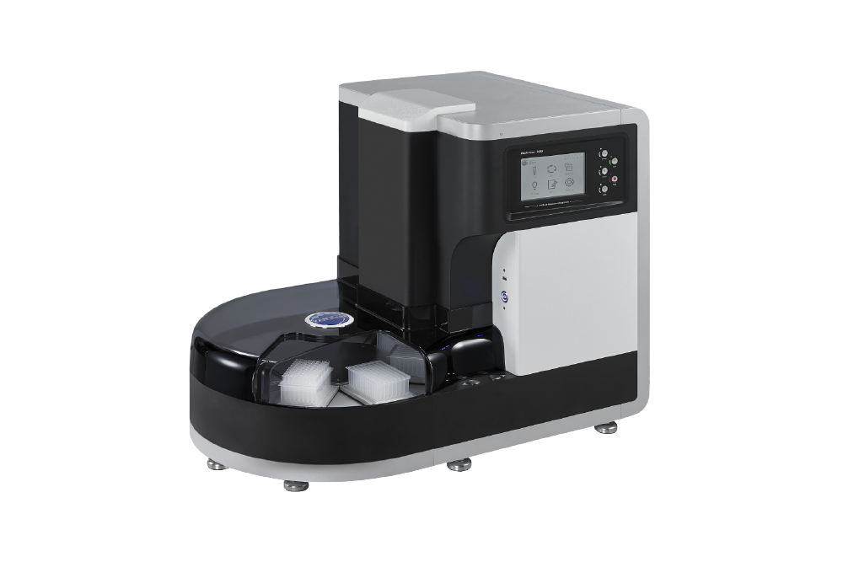

**Maelstrom 4800**

**Meet your demand for throughput**

Maelstrom 4800 is a standalone and compact automated nucleic acid extractor designed for low to medium-throughput applications. It extracts 1-48 samples quickly and efficiently with the unique Spin-tip technology the Maelstrom 4800 is equipped with a UV lamp and HEPA filter for decontamination, and everything is controlled with an easy-to-use touchscreen.

Fully Automated Simultaneous processing and purification of DNA, RNA samples

Patented Whirl Stirring Mixing Technology Processing volume up to 1,600µl

Time Saving 3,500 gauss magnetic rods efficiently collect magnetic beads with High stirring efficiency with variable speeds for considerable time savings

